4 NATIONS - ONE STRIKE
As the UK’s (inter)national university, the Open University crosses borders and enriches academic debate across the 4 nations. We’re part of a broad community that is united to fight for USS, fair pay and equality.
4 FIGHTS - ONE VOICE
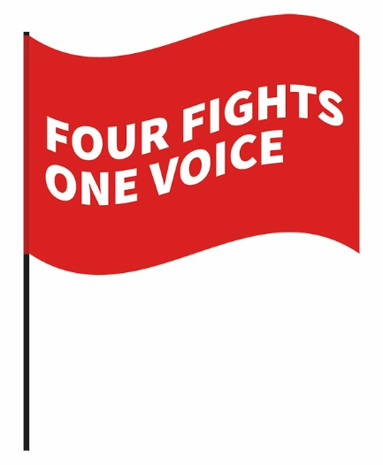
Every day of this strike, our colleagues are standing together with staff and students around the UK. Our issues are:
Job Security
Reasonable Workloads
Fair and Equal Pay
Pension Justice

OU staff members are picketing at 6 locations. Our homeworking colleagues are taking industrial action right across the 4 nations.
…FROM CARDIFF TO COVENTRY…FROM BATH TO BELFAST…
WE’RE UNITED
Find out why the National Union of Students supports this strike: https://youtu.be/cnVe-aXan8Y

